Ec2 challenges
- Launch one EC2 instance using Amazon Linux 2.
GO to aws and launch instance
Give name
Select AMI ( operating system)
The give pem.key
Check utilizations in networking and select how many instances you want to launch
I have choose 1 instance and launched the instance
Successfully instance will launched

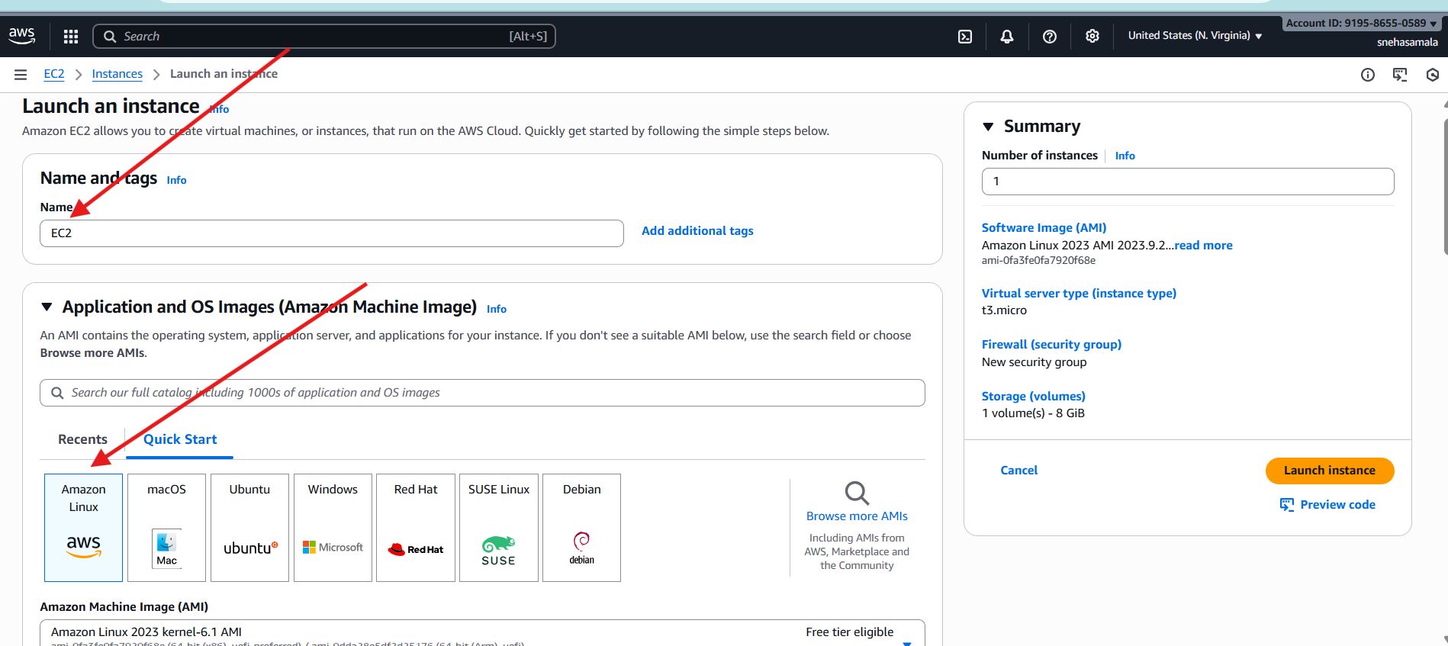
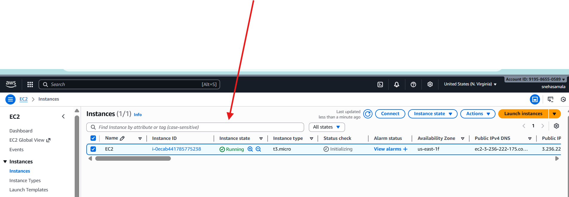
- Install Docker.
First connect to the local machine
Then go to the root user – sudo su –
Then install the docker : sudo yum install docker -y
Then successfully docker will installed
Then start the docker
Check the status of docker
Docker is active now
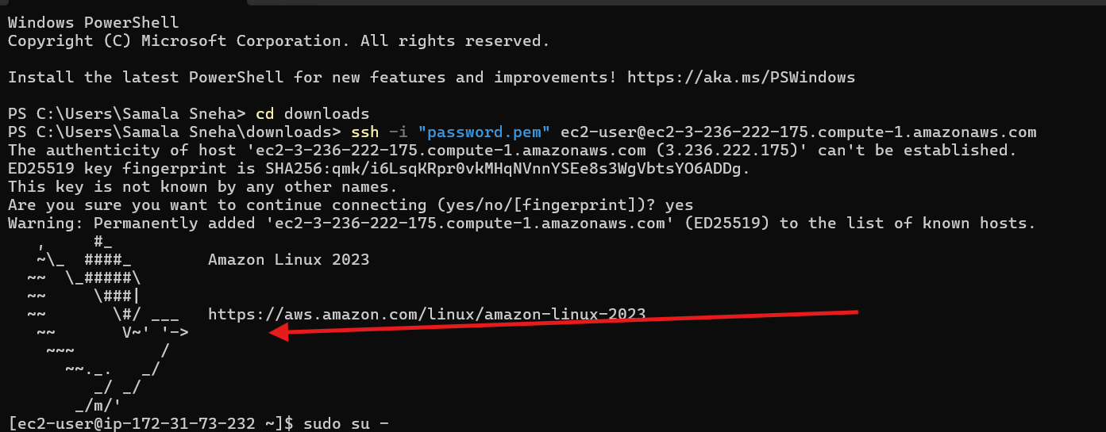
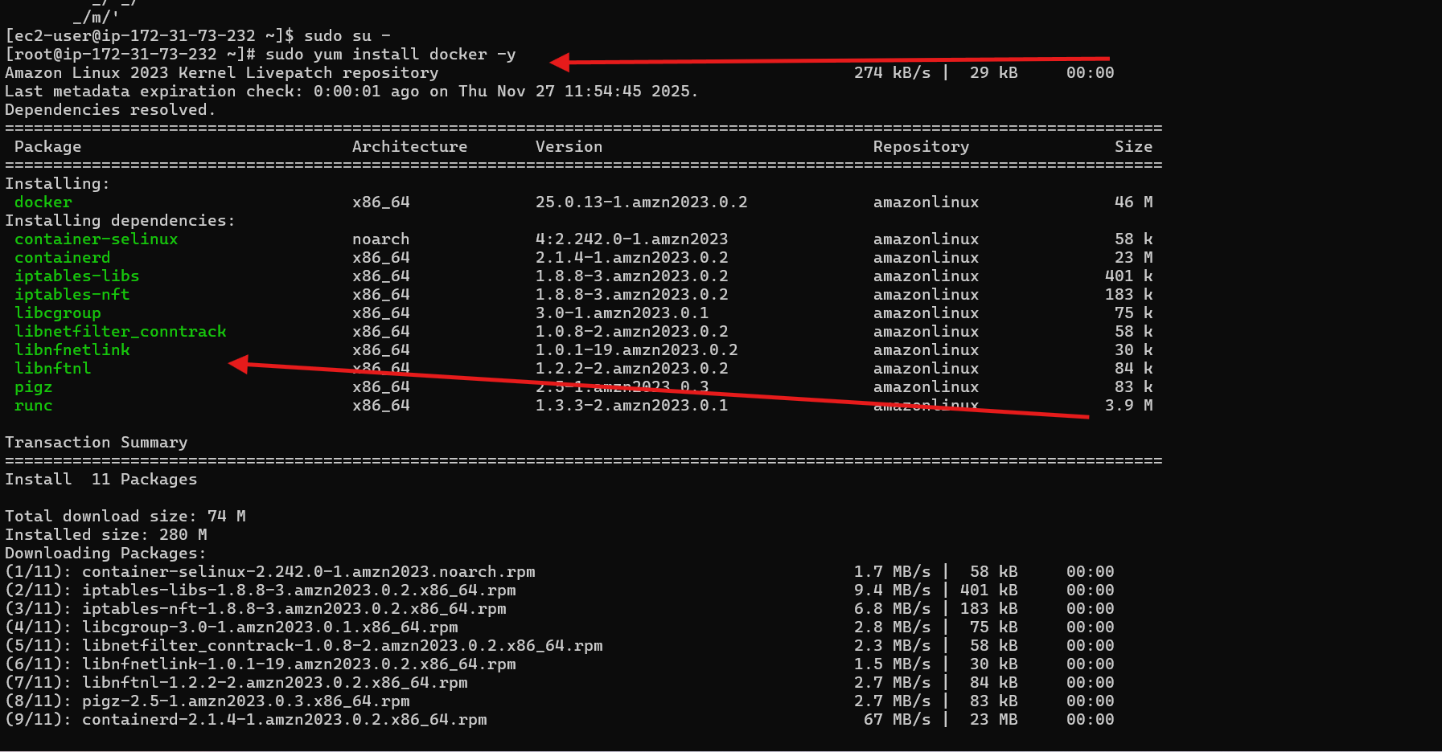
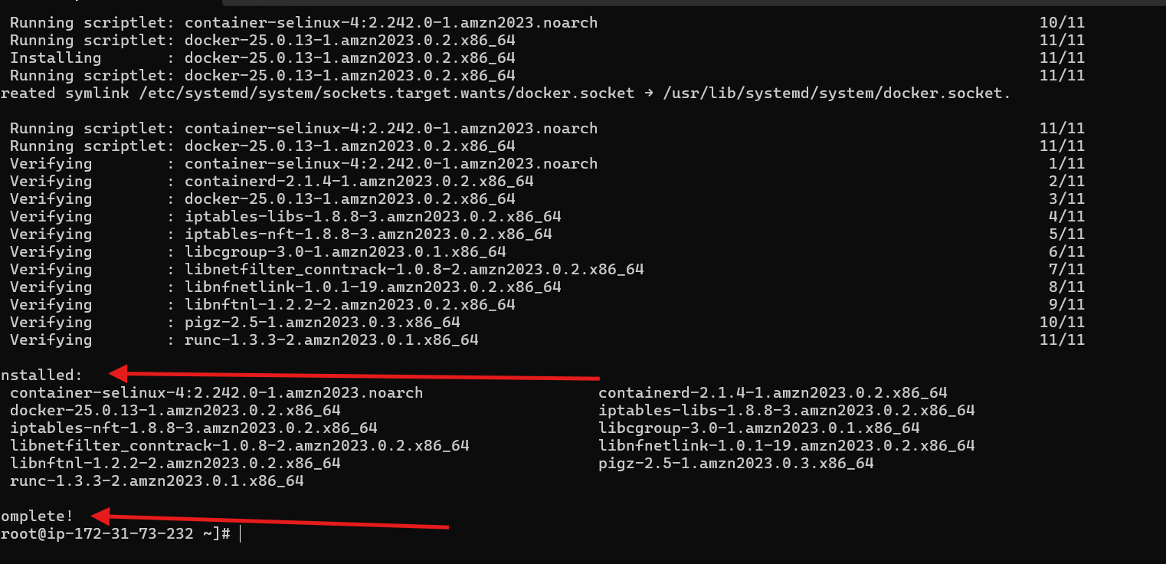
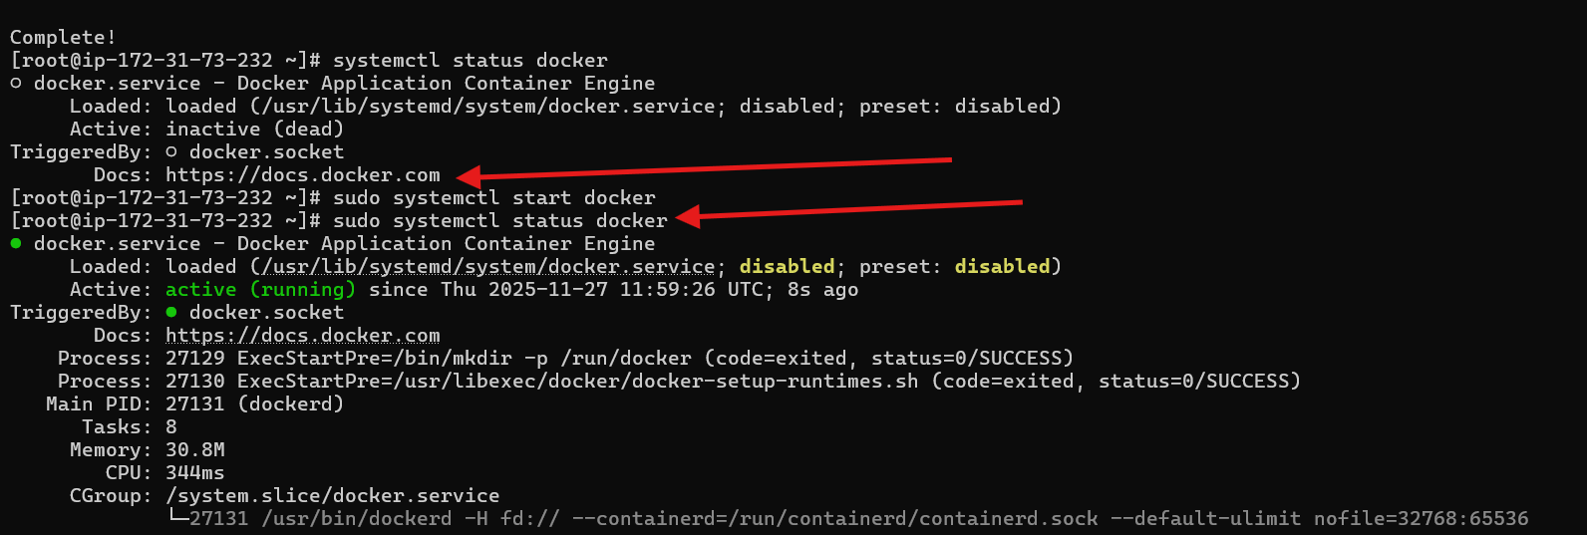
- Install Jenkins.
Install java
Check the version of java
Check the version of java
Java –version

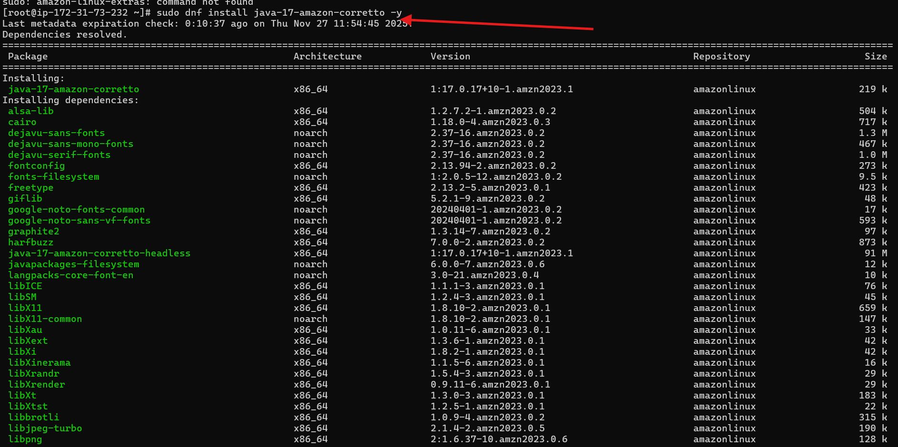
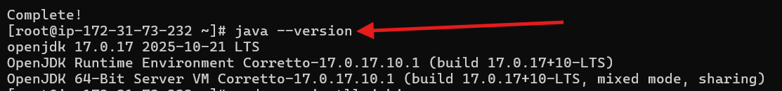
While installing the Jenkins if we will get wny kind of error
Use alternative commands to clear the error
sudo rpm --import https://pkg.jenkins.io/redhat-stable/jenkins.io-2023.key
sudo yum clean all
sudo yum install jenkins -y : install the Jenkins
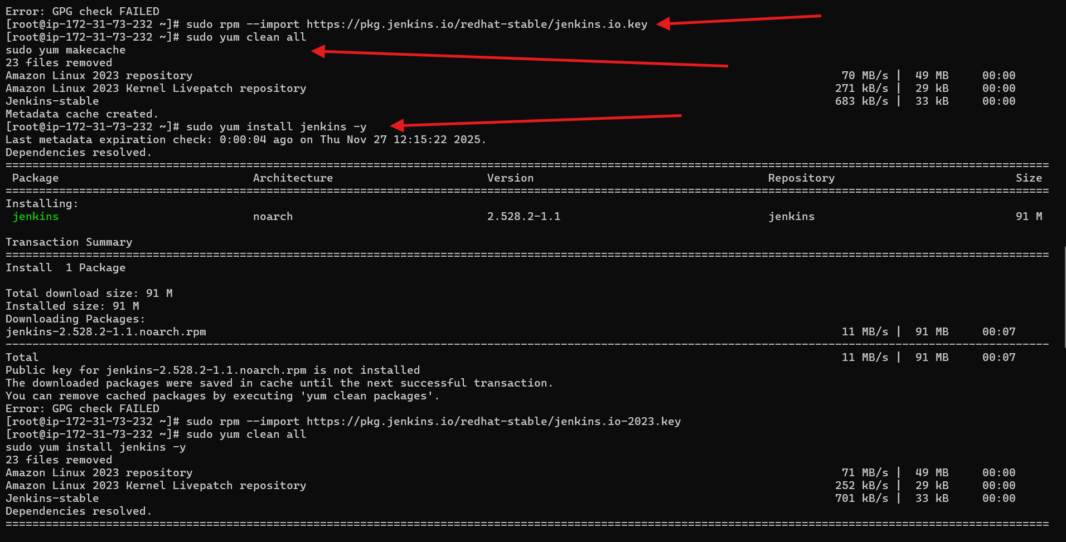
Vi /usr/lib/system/system/jenkins.service: by using this command we can change the port number
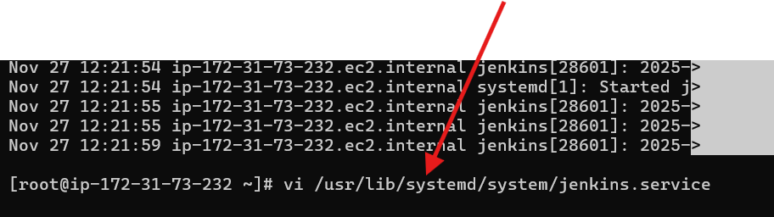
Change the port number hear : (8080 to 8081)
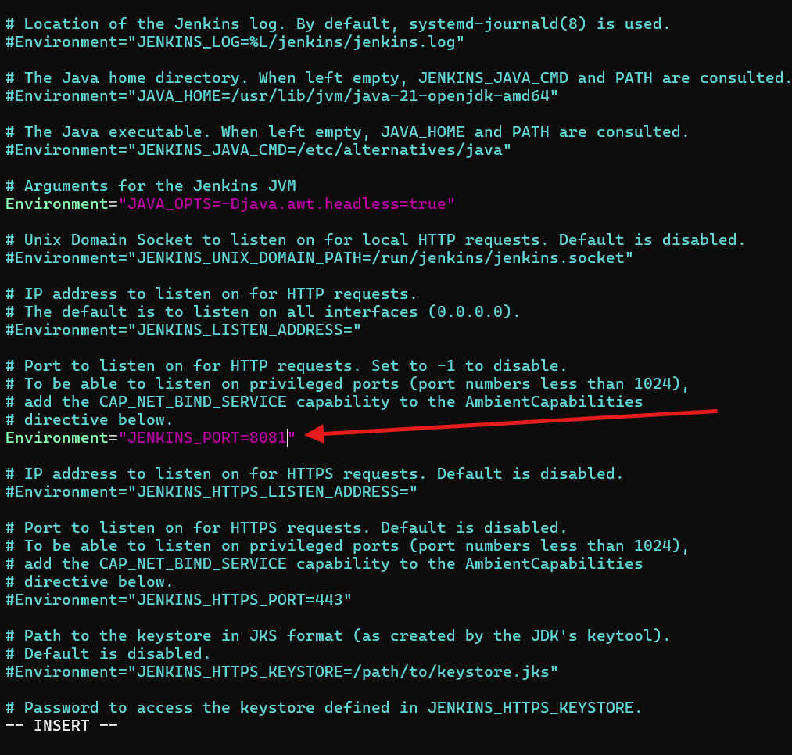
Demon-reload
Start Jenkins
Status Jenkins : active
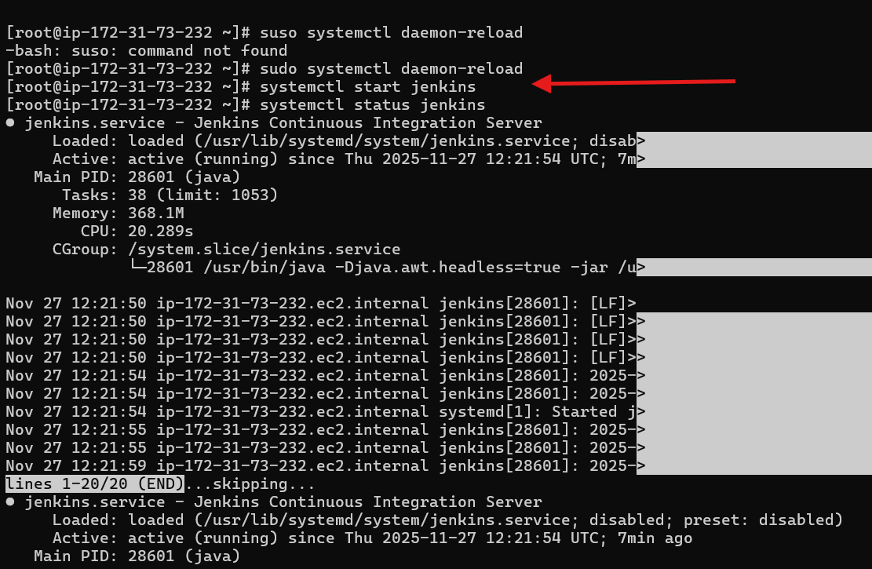
For example after adding te inbond rules also some time page is not found
Then again restart the Jenkins
Start the Jenkins
After go to the browser ad refresh the page it will get

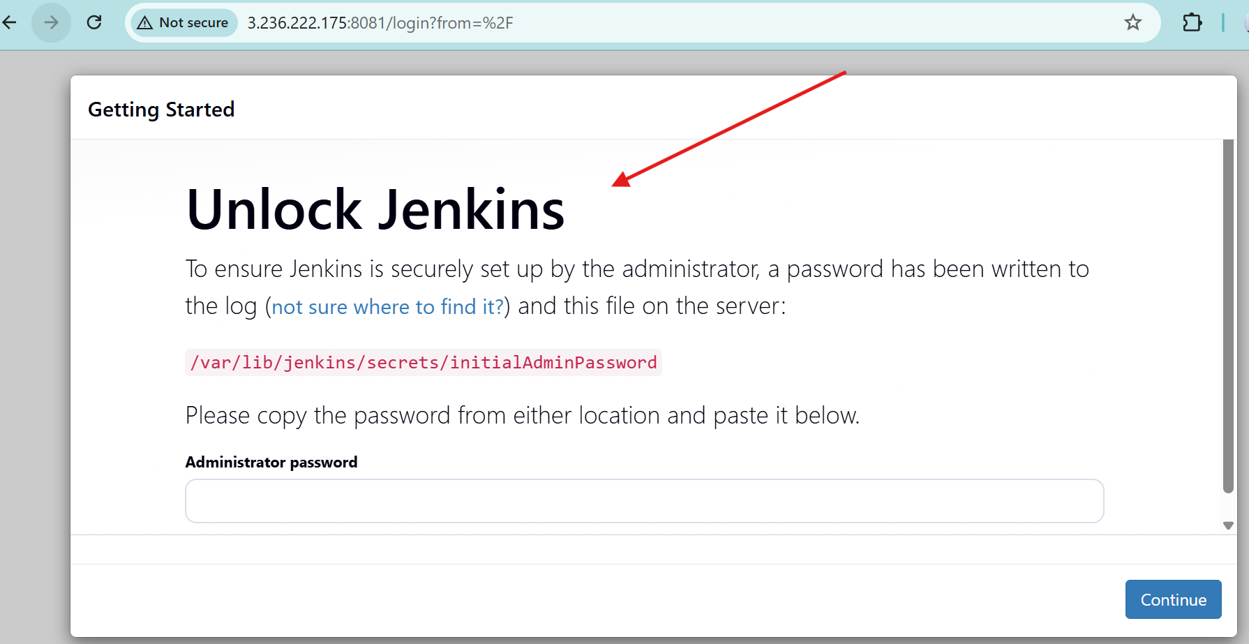
Cat the log /var/lib/Jenkins/secreats/initialAdminpassword
Then we will get the password
Enter the password to start the Jenkins
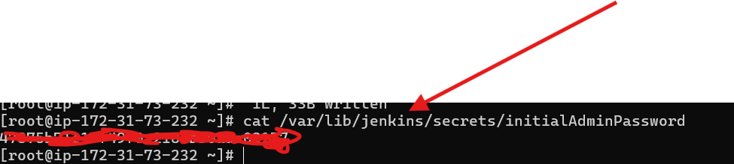

Jenkins is starting
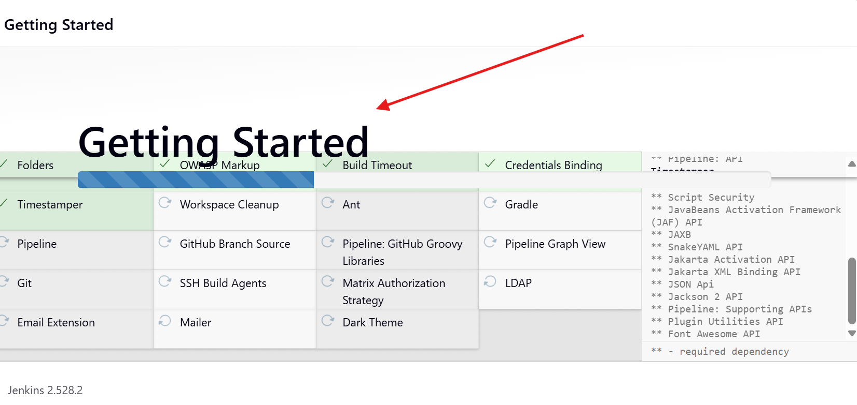
You will get the admin user
Add user and password also
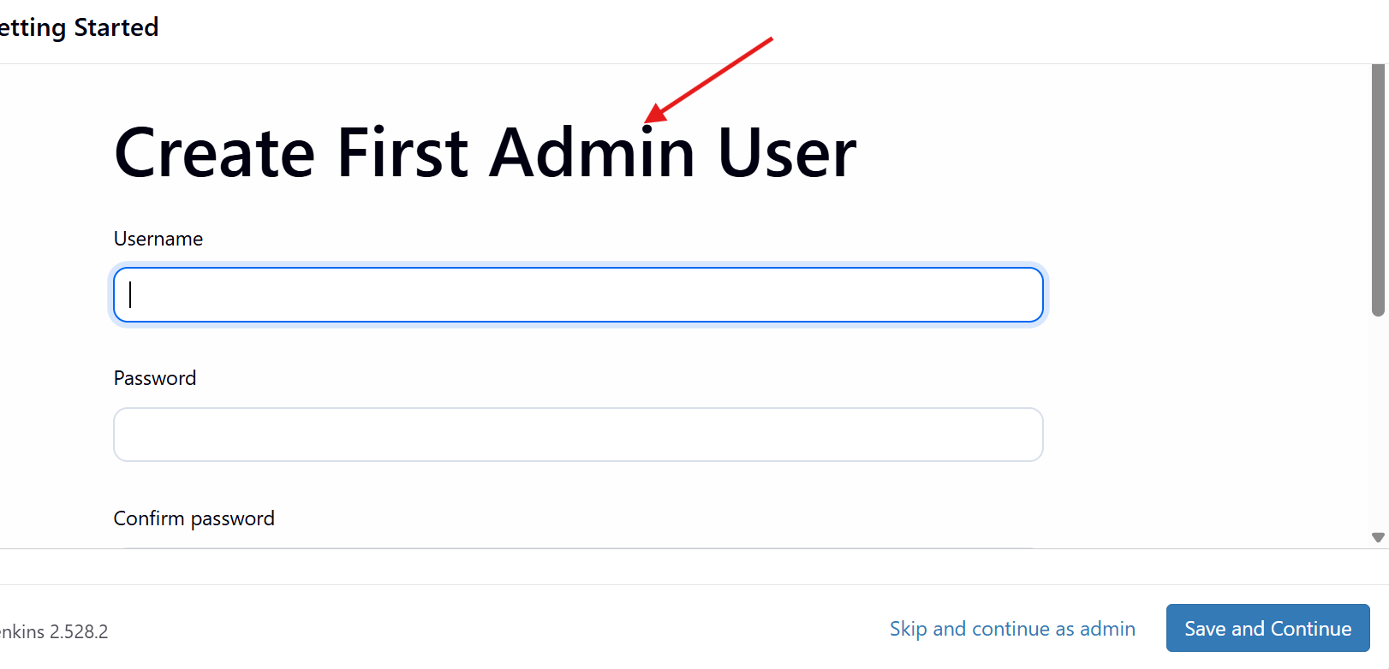
You will get the configuration page with Public URL
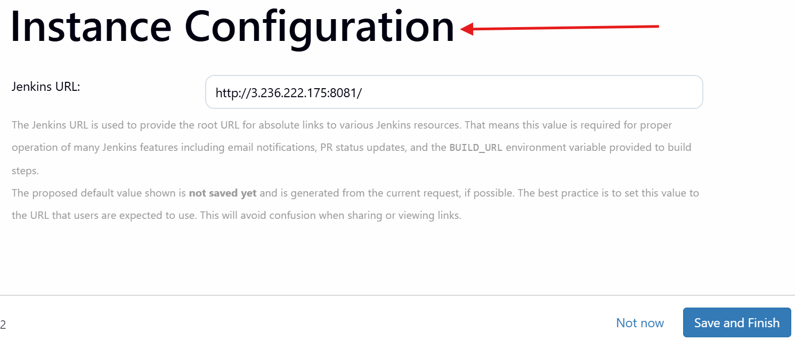
Start the Jenkins
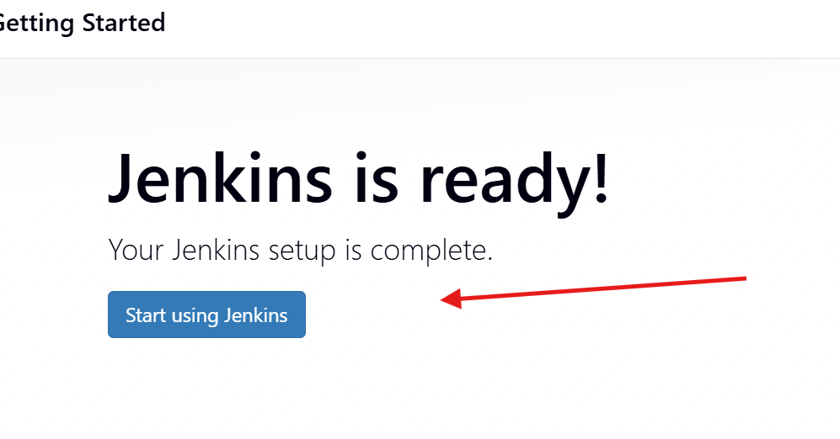
Jenkins page is hear
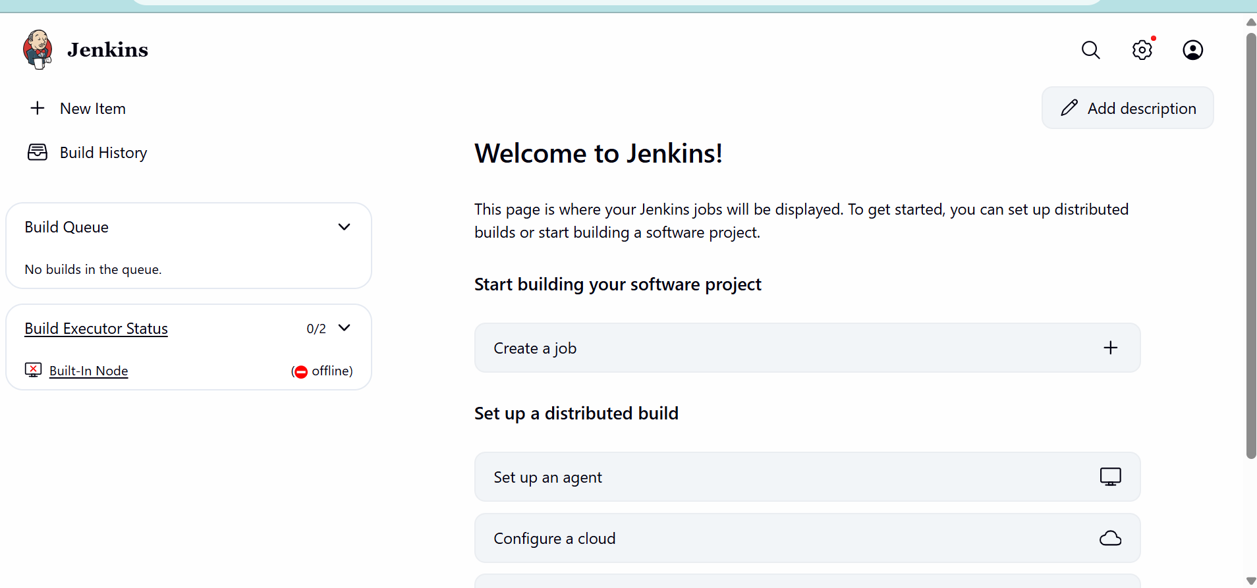

- Install Apache.
Install httpd -y
Start
Status
Make sure that port is 80
Then only
Copy the public ip
Go to the browser and chat apache is working or not
Successfully its working
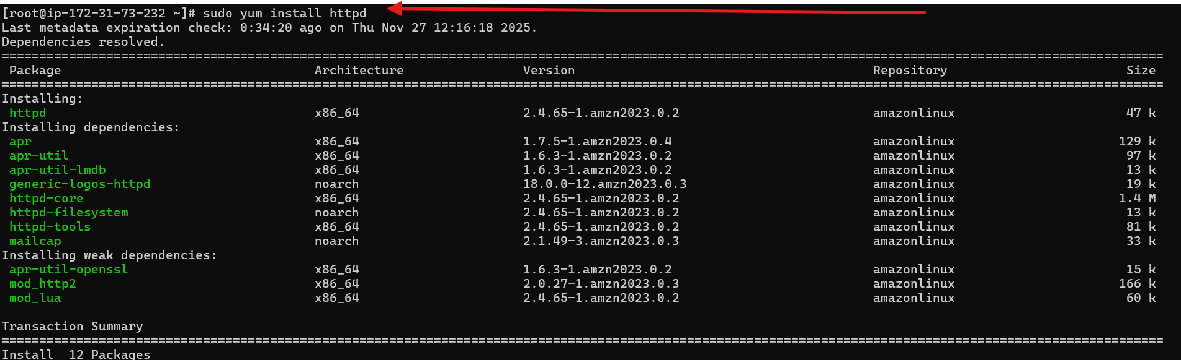
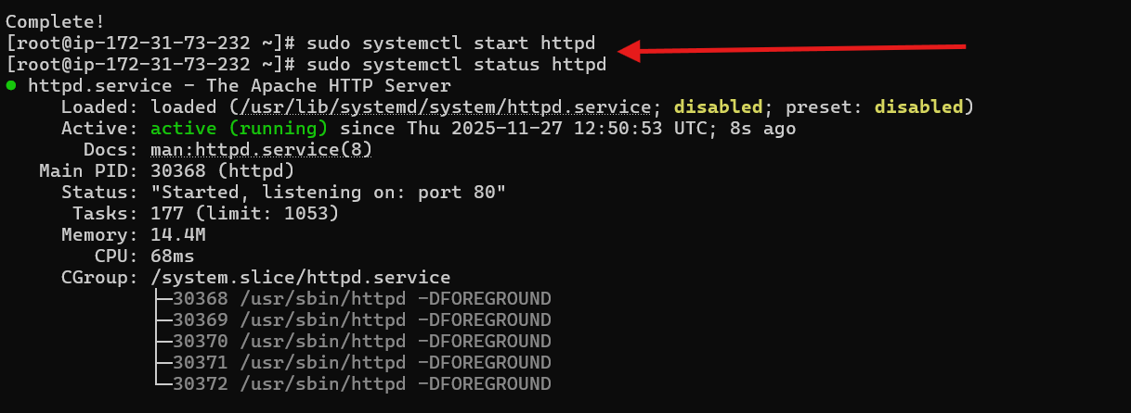
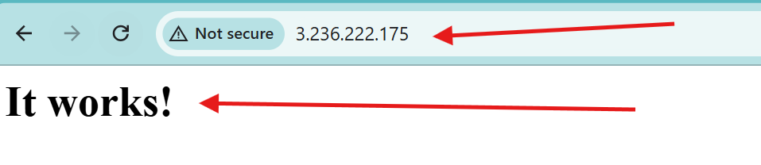

- Install Nginx.
Install nginx
Start nginx
Status nginx
For example while starting the nginx if you will get the error
Then stop the hpptd
Then again start and check the status of hpptd
Nginx is running successfully
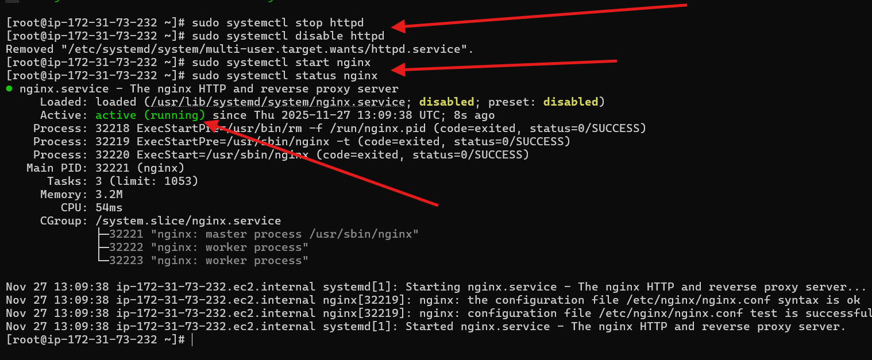
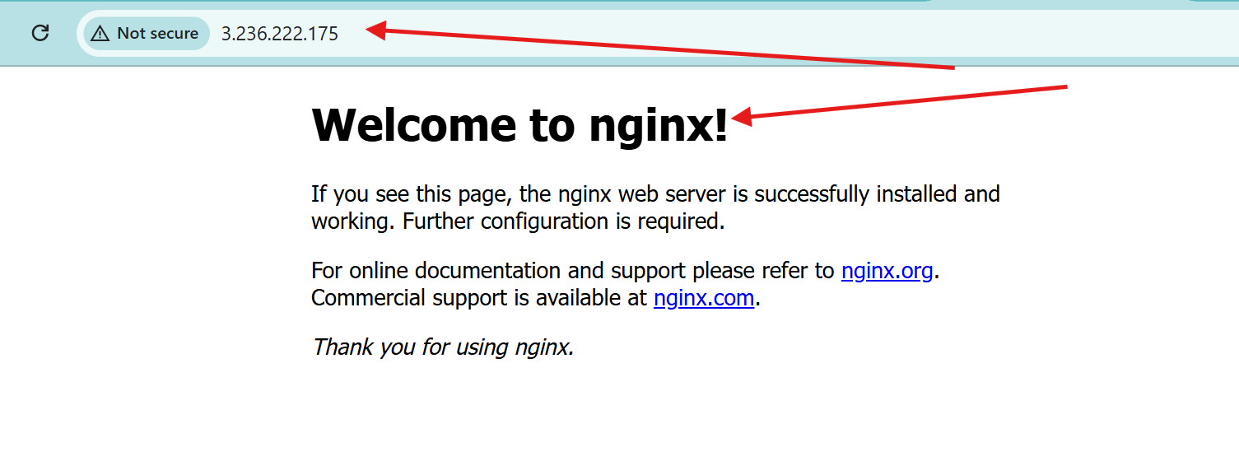
- Install Apache Tomcat.
Install apache tomcat with the link
Wget :
https://dlcdn.apache.org/tomcat/tomcat-9/v9.0.112/bin/apache-tomcat-9.0.112.tar.gz
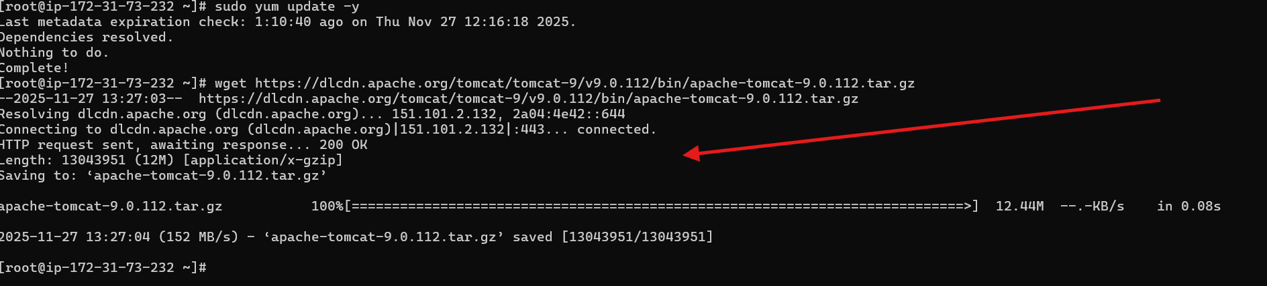
Check
Rename
Permissions
Start the tomcat
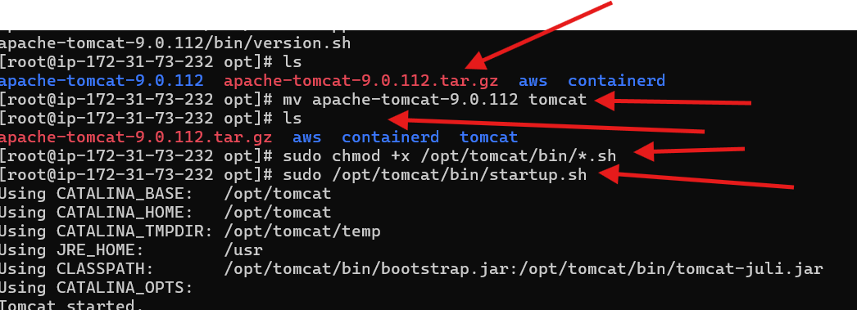
Change the directory of tomcat
Configure the directory
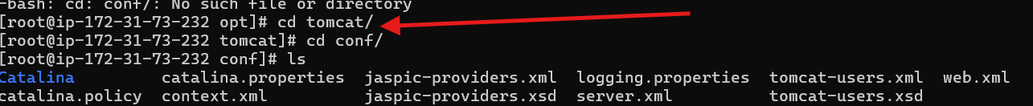
Then vi server.xml : we can change our port number by using this

Change your port number
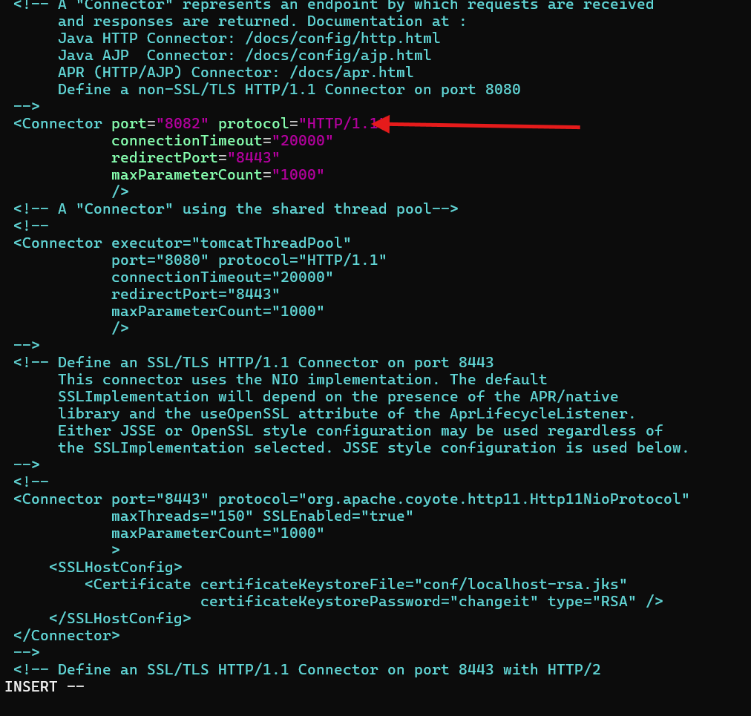
Shutdown
Start
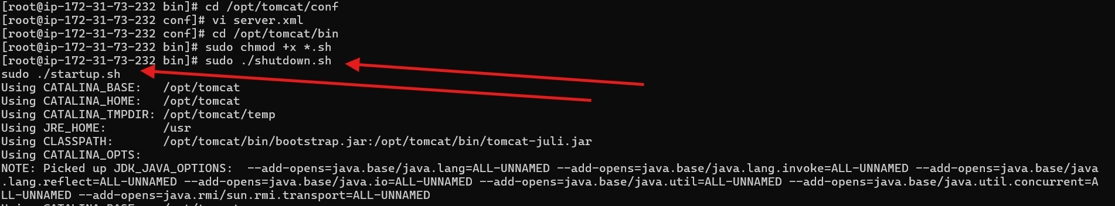
Go to the browser paste the public IP including with port number
Then tomcat will start successfully
